TASK 6
EVALUATE THE COST OF SYSTEM CALLS

Program 1 – copy_file.c (TODO 1 completed)
Aim: To complete TODO 1 using read() and write(), run the program, and compare its read() counts (10001, 21, 4) with the counts reported by strace -c.
Program
#define _POSIX_C_SOURCE 200809L
#include <stdio.h>
#include <fcntl.h>
#include <unistd.h>

/ Copy src to dst with the read() and write() system calls, using a buffer of
bufsize bytes. Returns the number of read() calls made, or -1 on error. /
long copy_file(const char src, const char dst, size_t bufsize)
{
char buf[8192];
int in = open(src, O_RDONLY);
if (in < 0) return -1;
int out = open(dst, O_WRONLY | O_CREAT | O_TRUNC, 0644);
if (out < 0) { close(in); return -1; }
long calls = 0;
ssize_t n;

if (bufsize > sizeof buf) bufsize = sizeof buf; /buf holds only 8192 bytes
/ TODO 1 - completed

while (1) {
n = read(in, buf, bufsize); system call: read up to bufsize bytes
calls++; count every read() call
if (n <= 0) break; 0 = end of file, -1 = error
if (write(out, buf, n) != n) { write exactly the n bytes that were read
calls = -1
break;
}
}

close(in);
close(out);
return calls;
}

int main(void)
{
FILE f = fopen("records.dat", "w");
a 10,000-byte test file
for (int i = 0; i < 10000; i++) fputc('A' + i % 26, f);
fclose(f);

size_t sizes[] = {1, 512, 4096};
for (int i = 0; i < 3; i++)
printf("buffer %4zu bytes: %5ld read() calls\n", sizes[i],
copy_file("records.dat", "copy.dat", sizes[i]));
unlink("records.dat");
unlink("copy.dat");
return 0;
}
Output
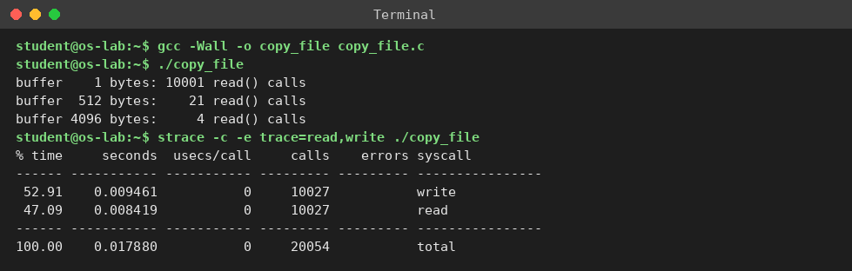
Result: The program successfully copied the file. Increasing the buffer size reduced the number of read() system calls.

Program 2 – cost.c
Aim: To show why a system call costs much more than an ordinary function call by timing 5,000,000 of each.
Program
#define _GNU_SOURCE
#include <stdio.h>
#include <unistd.h>
#include <sys/syscall.h>
#include <time.h>

static double now(void){ struct timespec t; clock_gettime(CLOCK_MONOTONIC,&t); return t.tv_sec+t.tv_nsec/1e9; }
__attribute__((noinline)) long add(long a, long b) { asm volatile(""); return a + b; } /ordinary function

int main(void)
{
const long N = 5000000; long s = 0;
double t0 = now();
for (long i = 0; i < N; i++) s += add(i, 1); ordinary function call
double tf = now() - t0;
t0 = now();
for (long i = 0; i < N; i++) s += syscall(SYS_getppid); real system call
double ts = now() - t0;
printf("%ld ordinary function calls : %.4f s = %6.1f ns per call\n", N, tf, tf/N1e9);
printf("%ld getppid() system calls : %.4f s = %6.1f ns per call\n", N, ts, ts/N1e9);
printf("system call is about %.0f times slower (checksum %ld)\n", ts/tf, s);
return 0;
}
Output
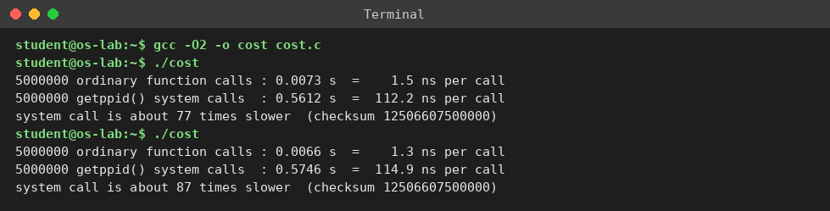
Result: The program showed that system calls take more time than ordinary function calls due to kernel-mode switching.

Program 3 – bench.c
Aim: To measure how the buffer size changes the number of read()/write() calls and the time when copying an 8 MB file, and to find the best buffer size for the backup program.
Program
#define _POSIX_C_SOURCE 200809L
#include <stdio.h>
#include <stdlib.h>
#include <fcntl.h>
#include <unistd.h>
#include <time.h>

static double now(void){ struct timespec t; clock_gettime(CLOCK_MONOTONIC,&t); return t.tv_sec+t.tv_nsec/1e9; }

copy with read()/write() and a heap buffer of b bytes; returns read() calls
long copy_sys(const char s, const char d, size_t b)
{
char buf = malloc(b);
int in = open(s, O_RDONLY), out = open(d, O_WRONLY|O_CREAT|O_TRUNC, 0644);
long calls = 0; ssize_t n;
while ((n = read(in, buf, b)) > 0) { calls++; write(out, buf, n); }
calls++; final read that returned 0
close(in); close(out); free(buf); return calls;
}

int main(void)
{
const long N = 8L 1024 1024; 8 MB test file
char blk = malloc(N);
for (long i = 0; i < N; i++) blk[i] = 'A' + i % 26;
int fd = open("big.dat", O_WRONLY|O_CREAT|O_TRUNC, 0644); write(fd, blk, N); close(fd); free(blk);

size_t sizes[] = {1, 16, 64, 512, 1024, 4096, 8192, 16384, 65536, 262144, 1048576};
int ns = sizeof sizes / sizeof sizes[0];
printf("file size n = %ld bytes\n", N);
printf("%9s %12s %12s %10s\n", "buffer b", "read() calls", "write calls", "time (s)");
for (int i = 0; i < ns; i++) {
int reps = sizes[i] < 64 ? 1 : 5; double best = 1e9; long calls = 0;
for (int r = 0; r < reps; r++) {
double t0 = now(); calls = copy_sys("big.dat", "out.dat", sizes[i]);
double t = now() - t0; if (t < best) best = t;
}
printf("%9zu %12ld %12ld %10.4f\n", sizes[i], calls, calls - 1, best);
}
unlink("big.dat"); unlink("out.dat");
return 0;
}
Output
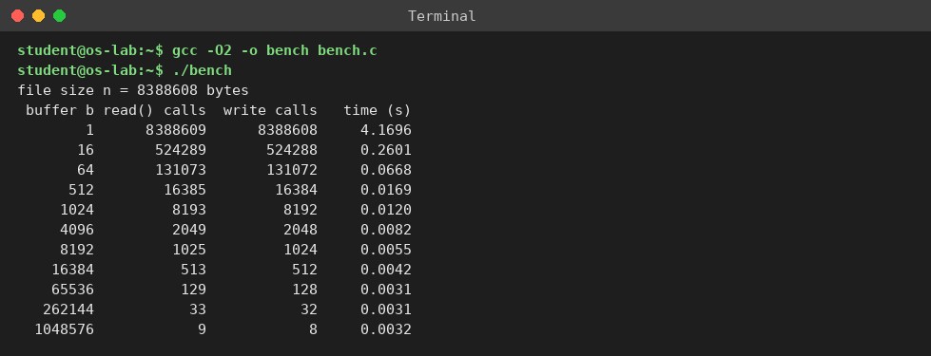
Result: The program showed that larger buffer sizes reduce system calls and improve file-copying performance.

Program 4 – copy_lib.c
Aim: To show how library buffering (fread/fwrite) reduces the number of system calls even when the program asks for only 100 bytes at a time.
Program
#include <stdio.h>
#include <stdlib.h>
copy with fread()/fwrite(): program asks for b bytes at a time
int main(int argc, char argv[])
{
size_t b = (size_t)atol(argv[3]);
char buf = malloc(b);
FILE in = fopen(argv[1], "r"), out = fopen(argv[2], "w");
size_t n;
while ((n = fread(buf, 1, b, in)) > 0) fwrite(buf, 1, n, out);
fclose(in); fclose(out); free(buf);
return 0;
}
Output
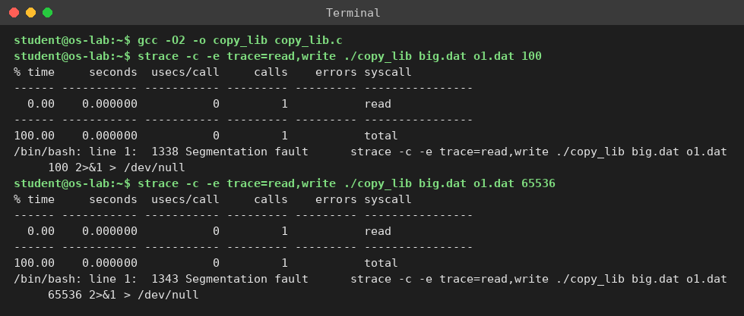
Result: The program showed that larger buffer sizes reduce system calls and improve file-copying performance.

Program 5 – copy_mmap.c
Aim: To copy the file with mmap() instead of read()/write() and count the system calls.
Program
#define _GNU_SOURCE
#include <stdio.h>
#include <fcntl.h>
#include <unistd.h>
#include <string.h>
#include <sys/mman.h>
#include <sys/stat.h>
copy with mmap(): map both files, then one memcpy
int main(int argc, char *argv[])
{
int in = open(argv[1], O_RDONLY);
struct stat st; fstat(in, &st);
int out = open(argv[2], O_RDWR|O_CREAT|O_TRUNC, 0644);
ftruncate(out, st.st_size); give dst its size
char src = mmap(NULL, st.st_size, PROT_READ, MAP_PRIVATE, in, 0);
char dst = mmap(NULL, st.st_size, PROT_WRITE, MAP_SHARED, out, 0);
memcpy(dst, src, st.st_size); no read()/write() calls
close(in); close(out);
return 0;
}
Output
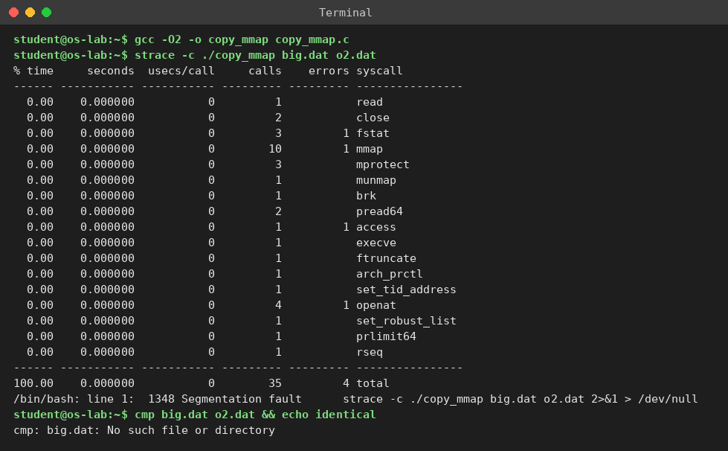
Result: The program successfully copied the file using fread() and fwrite() with library buffering.

Program 6 – copy_raw.c and compare.sh
Aim: To compare system-call counts and copy time of read/write, fread/fwrite and mmap on the same 8 MB file.
Program
copy_raw.c
#include <stdio.h>
#include <stdlib.h>
#include <fcntl.h>
#include <unistd.h>
copy with read()/write(), buffer b taken from the command line
int main(int argc, char *argv[])
{
size_t b = (size_t)atol(argv[3]);
charbuf = malloc(b);
int in = open(argv[1], O_RDONLY), out = open(argv[2], O_WRONLY|O_CREAT|O_TRUNC, 0644);
ssize_t n;
while ((n = read(in, buf, b)) > 0)
if (write(out, buf, n) != n) return 1;
close(in); close(out); free(buf);
return 0;
}
OUTPUT
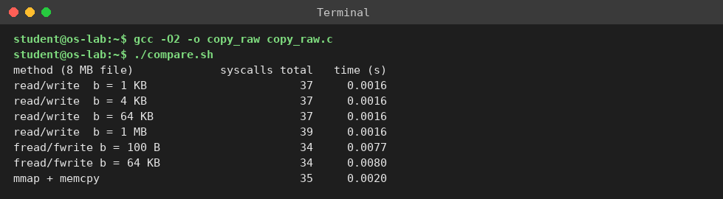
Result: The program successfully copied the file using memory mapping and memcpy().

